Sevenoaks Conservative Association

DUNTON GREEN & RIVERHEAD BRANCH
jointly with
OTFORD & SHOREHAM BRANCH
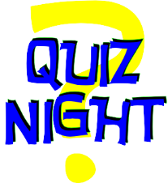
A Quiz Night
With Fish and Chip Supper
(and glass of wine)
On
Friday November 15th 7pm to 9pm

St Marys Church Hall
Riverhead
Sevenoaks TN13 2BS
(Access from Shoreham Lane to car park)

Cost £22 per ticket
Quiz, fish, and chips (or chicken/vegetarian/vegan alternative), drink
To purchase tickets, contact: jillwadie@btinternet.com
Tel 01732 451091 or complete the slip below

 -----------------------------------------------------------------

Name………………………………......... Tel No…............................................

Email…………………………………………. No tickets………………Cost £……………..

Food Order…………………………………………………………………………………………..

PAY BY BACS: Conservative Association, Dunton Green & Riverhead
SORT CODE 30-97-49 ACC NO 00759052
Or BY CHEQUE payable to Conservative Association, Dunton Green and Riverhead c/o Jill Wadie, 6 The Patch, Riverhead, Sevenoaks TN13 2DH
Please bring cash on the evening for raffle and games.

