 **Sevenoaks Supper Club**

**Friday 1st November 2024**

**7pm for 7.30pm**

**Sevenoaks Indoor Bowls Club**

**Hollybush Close, Sevenoaks, TN13 3UX.**

**Special Guest: Actor & Writer, David Barry**

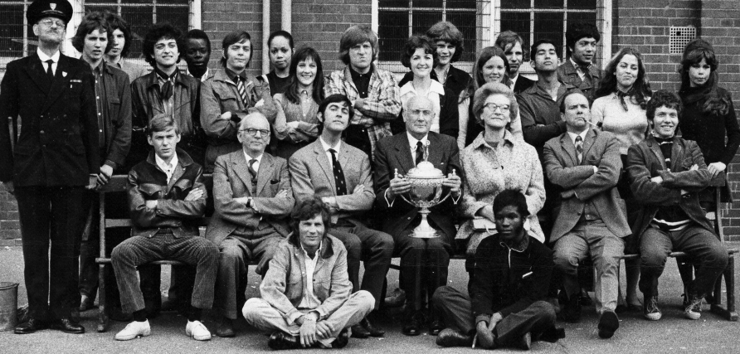David will speak to us about his career as an actor and writer. He has worked with many great actors including the great cast from ‘Please Sir!’ and ‘The Fenn Street Gang’. He wrote scripts for ‘Keep It in The Family’ for Thames TV and commissioned to write scripts for Alan J. W. Bell, Humphrey Barclay, BBC Wales and Working Title. His first novel, ‘Each Man Kills’, was published in 2002 and many crime and mystery books followed.

**MENU CHOICES**:

**Main Course**: Beef bourguignon with cream of mashed potatoes.

**Or**  Homemade mushroom wellington with seasonal vegetables.

**Dessert:** Homemade caramel cheesecake.

**Or** Cheese & Biscuits

Coffee/tea and mints

**PRICE £28**

When booking, please indicate which main course you prefer and if you want cheese and biscuits instead of dessert. Menu choices cannot be made on the night. If you have chosen vegetarian or C/B you will be given a label to display to ensure you receive your choices.

To book please email**:** [**SSCBookings@hotmail.com**](mailto:SSCBookings@hotmail.com) **07799885795**

Bank transfers preferred please, by Monday 28th Oct. Payment on the night is cheque or cash.

Name of Account: Sevenoaks Supper Club 2023

A/c No.: 44423968 Sort Code: 30-99-50 Ref: Your surname and initials.

Bookings Deadline: **NOON on MONDAY 28th October**

Cancellations after that time will be charged or credited to another month if resold.

***We*** ***look forward to seeing you at Supper Club on the 1st November. Guests are always very welcome.***